**Survey Description and Reference**

Contract: PAC/20181120/02

Contractor: Travis Sondgerath MS, MPH

Contents

Downloading and Submitting Data Using ODK Collect 3

Equipment Information Form Description 10

Equipment Activity Form Description 13

Request Calibration Form Description 15

Request Maintenance Form Description 15

# Downloading and Submitting Data Using ODK Collect

Data can be submitted to Ona forms using a web browser where an internet connection is available using a PC. However, when data must be collected in the field, where internet connection may not be available, the ODK Collect mobile application for Android devices is the best choice.

In order to submit forms to Ona, first request permission to access forms via ODK Collect by sending an email to [pacafenet@gmail.com](mailto:pacafenet@gmail.com) with your Ona user name included in the email. An Ona account can be created [here](https://ona.io/login) if you do not already have one. Additionally, email this address to request changes to forms hosted in Ona.

Below is a series of screen grabs walking through the process of downloading and using the ODK Collect app to download and fill in blank web forms hosted in Ona. Any url’s shown in the below screen grabs are generic and do not relate to the present project. You will need internet connection to setup your account and connect to forms.

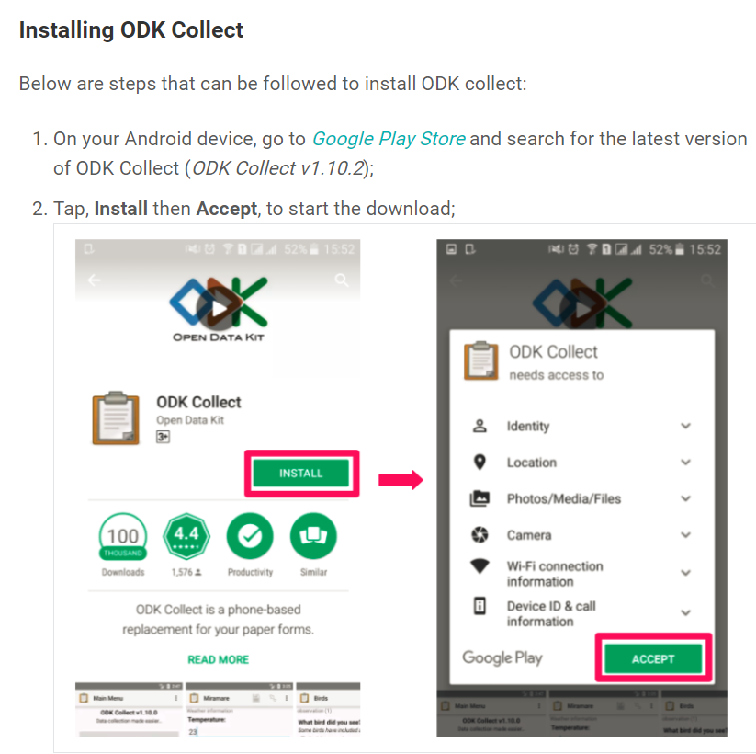

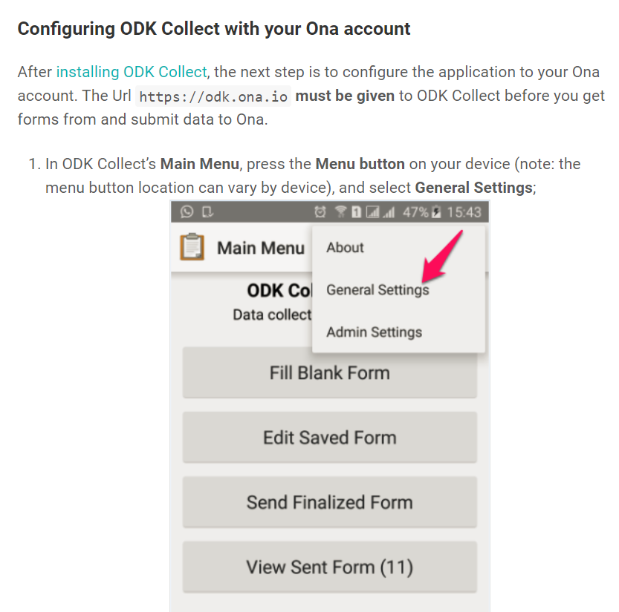

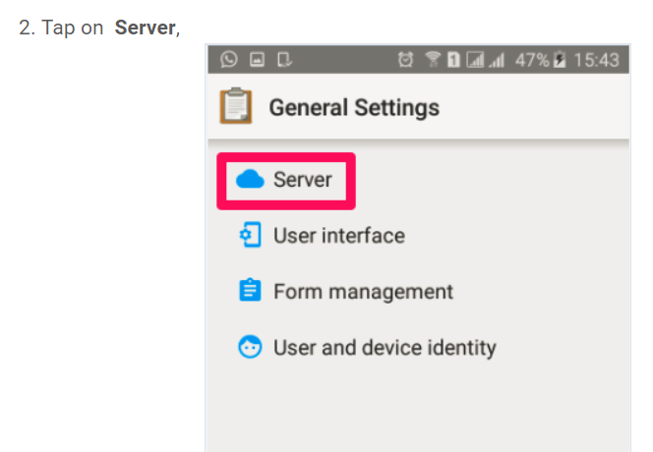

The url shown below can be used for **any** Ona forms.

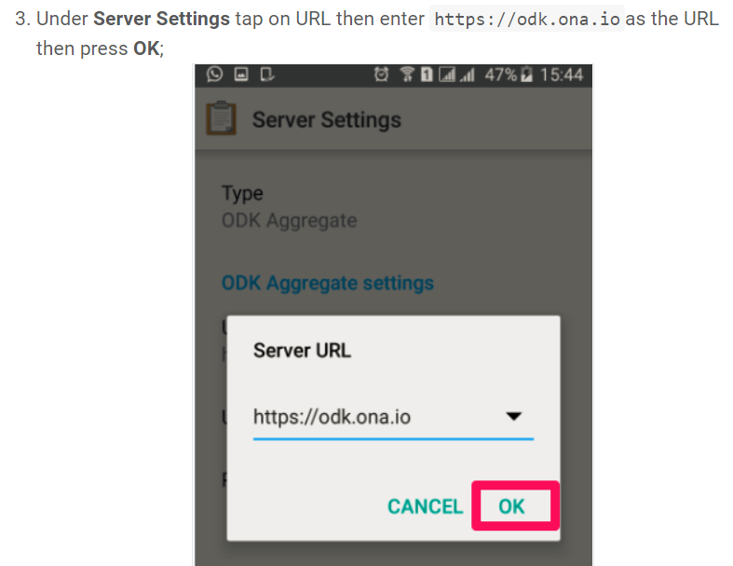

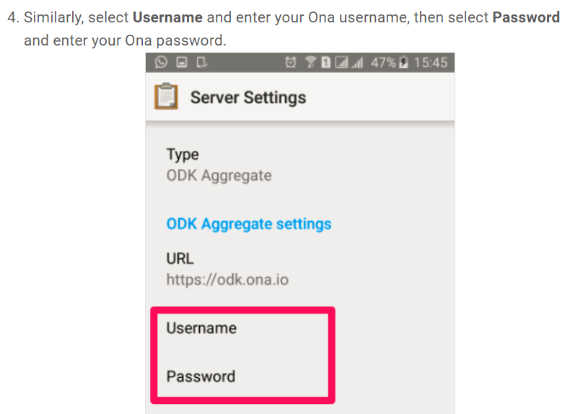

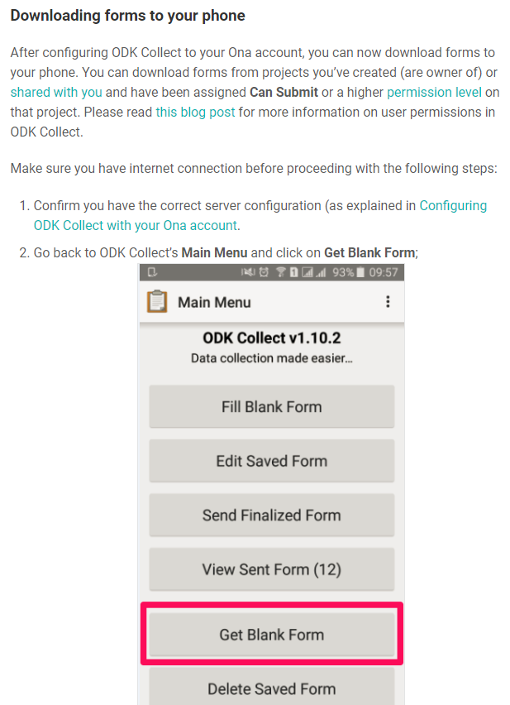

The project forms shown will differ from those below. Each is discussed in detail in other sections of this document.

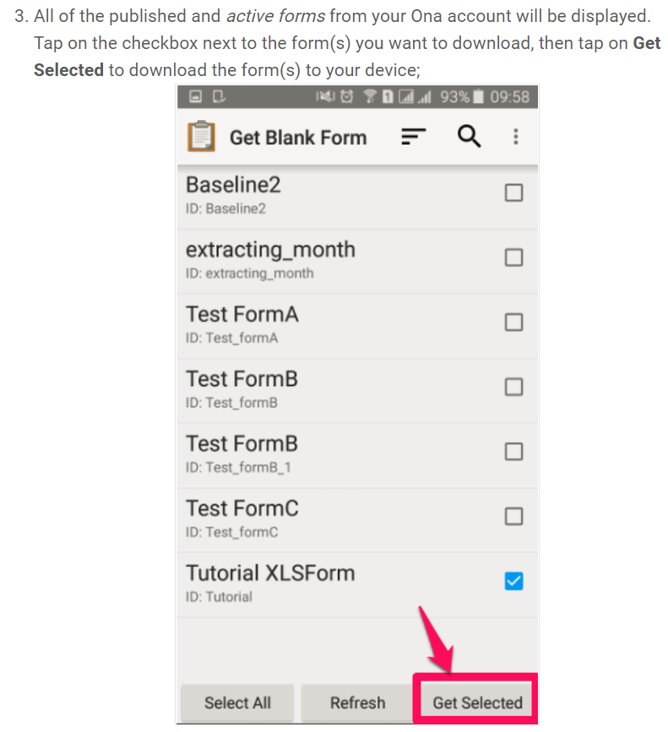

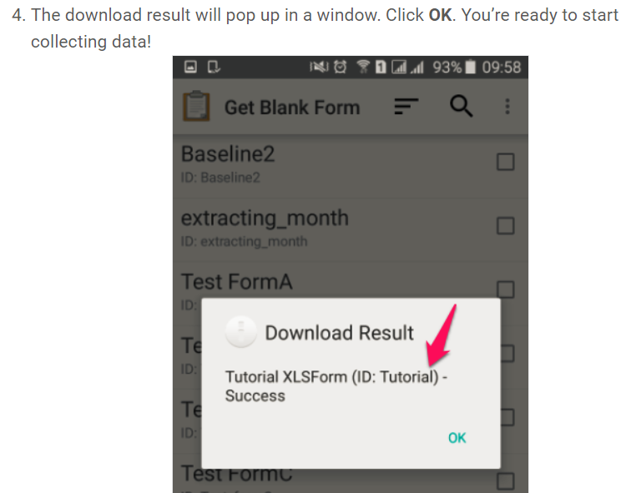

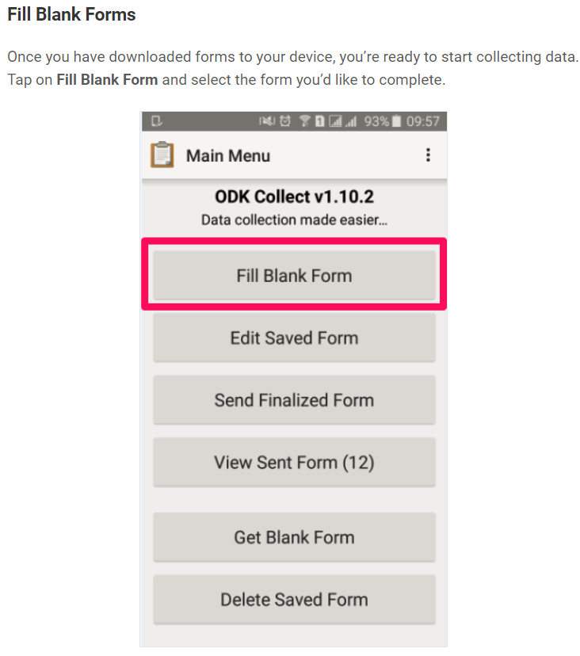

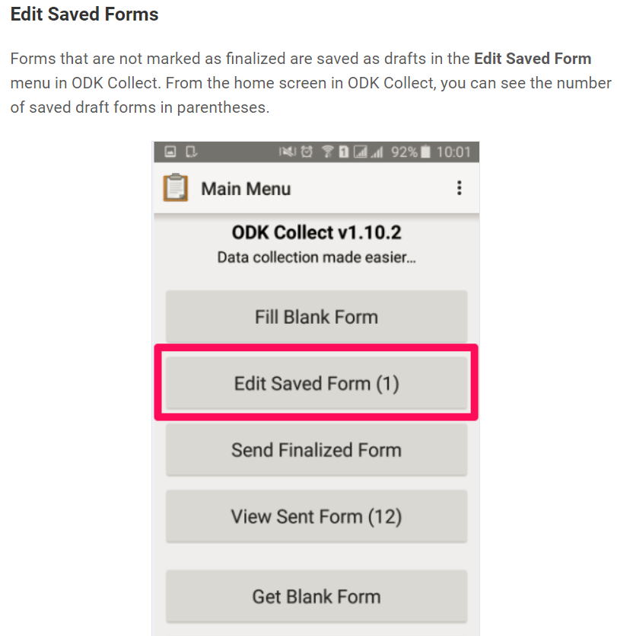

Once finished you will need to send any forms you have filled in to ‘finalize’ when you have internet connection if you did not when filling out forms. Before forms are finalized, your responses are saved in your mobile device’s web browser. Be sure to **not** delete your cookies and browsing history on your device until the form is finalized and sent.

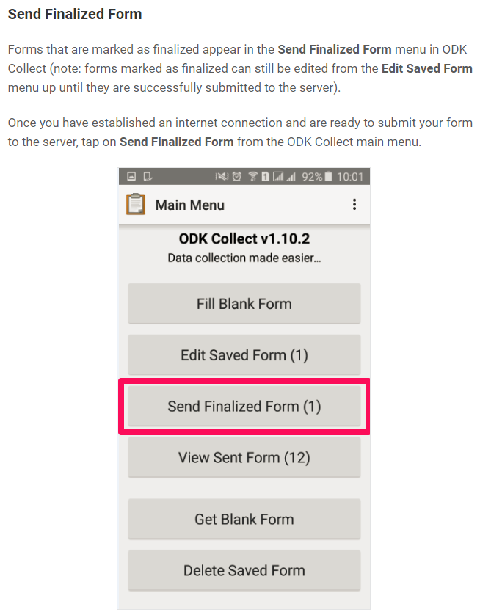

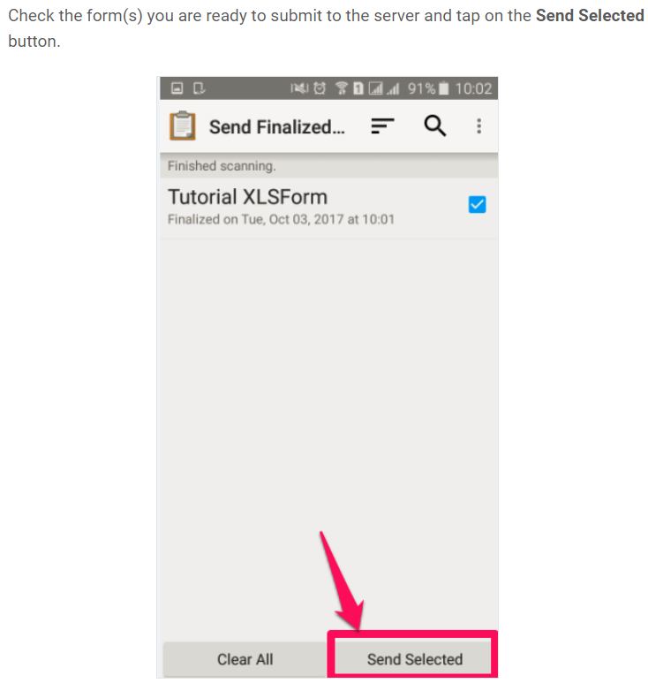

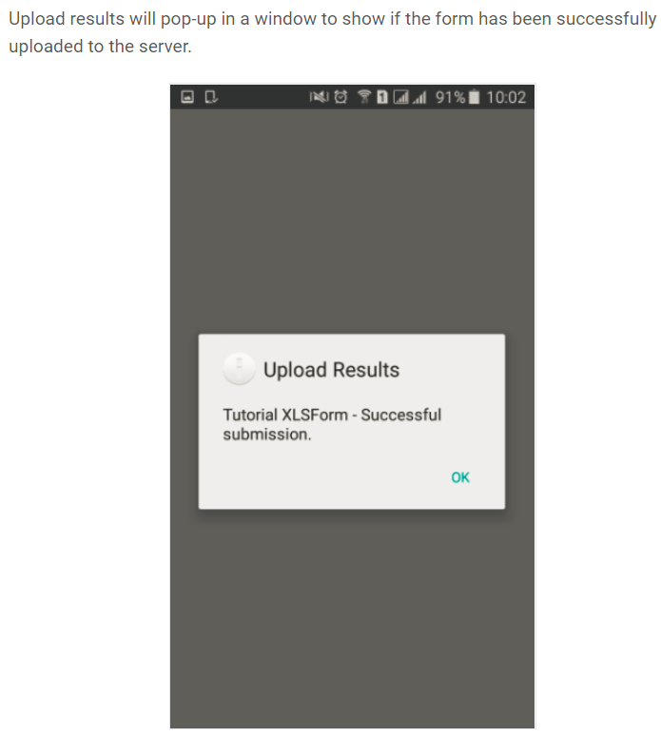

For additional details, go [here](https://help.ona.io/knowledge-base/guide-using-enketo-odk-collect/#odk-collect) for a detailed user guide published by Ona.

# Equipment Information Form Description

**Form url:** <https://enketo.ona.io/x/#xsR3wR1v>

**Form ID:** as shown in ODK Collect: build_New-Equipment-Form_1572890651

**Summary:** Used this form to enter new equipment data or to alter data for existing equipment. Please attempt to obtain all information before filling out this form for new equipment. Additionally, this form can be used to alter equipment information for equipment already in use. For example, if a piece of equipment’s location has changed re-enter the other information in the form and alter the location using the appropriate form question. To obtain the most recent data on that piece of equipment visit the [eTool](https://travis-shinin-spot.shinyapps.io/ona_reporting_app/) and lookup the relevant information for that piece of equipment.

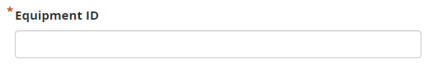

Type in the equipment ID, can be a number, letters, or a combination of these.

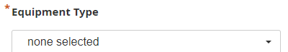

Choose one of the options provided. If the equipment type you are entering does not match those provided, send a message to [pacafenet@gmail.com](mailto:pacafenet@gmail.com) to request additional options be added.

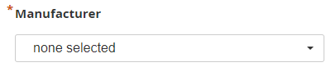

Choose one of the options provided. If the equipment manufacturer you are entering does not match those provided, send a message to [pacafenet@gmail.com](mailto:pacafenet@gmail.com) to request additional options be added.

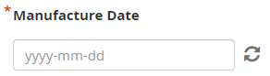

Select the date the equipment was manufactured.

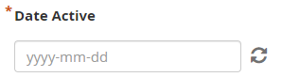

Select the date the equipment was first introduced to the lab.

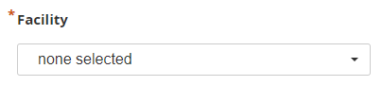

Choose one of the options provided. If the lab you are entering does not match those provided, send a message to [pacafenet@gmail.com](mailto:pacafenet@gmail.com) to request additional options be added.

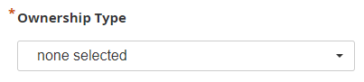

Choose one of the options provided. Select the closest value possible. Enter parochial if the facility housing the equipment is a faith-based organization.

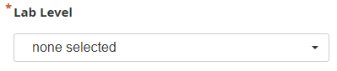

Choose one of the options provided. Select the closest value possible.

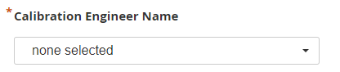

Choose one of the options provided. If the engineer name does not match those provided, send a message to [pacafenet@gmail.com](mailto:pacafenet@gmail.com) to request additional options be added.

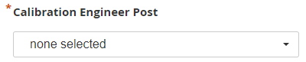

Choose one of the options provided. If the engineer post does not match those provided, send a message to [pacafenet@gmail.com](mailto:pacafenet@gmail.com) to request additional options be added.

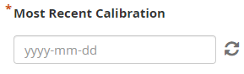

Enter the date of the most recent calibration event for the equipment.

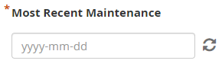

Enter the date of the most recent maintenance event for the equipment.

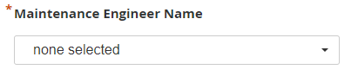

Choose one of the options provided. If the engineer post does not match those provided, send a message to [pacafenet@gmail.com](mailto:pacafenet@gmail.com) to request additional options be added.

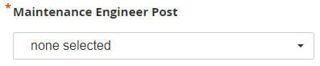

Choose one of the options provided. If the engineer post does not match those provided, send a message to [pacafenet@gmail.com](mailto:pacafenet@gmail.com) to request additional options be added.

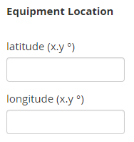

Enter the equipment latitude and longitude if known.

# Equipment Activity Form Description

**Form url:** <https://enketo.ona.io/x/#JBXgIyIf>

**Form ID as shown in ODK Collect:** build_Equipment-Activity-Form_1572919467

**Summary:** Use this form primarily to document maintenance and calibration activities. Additionally, this form can be used to alter the equipment engineer name and post. Lastly, this is the only form that can be used to indicate that equipment should be removed from circulation and should not be included in future maintenance activities.

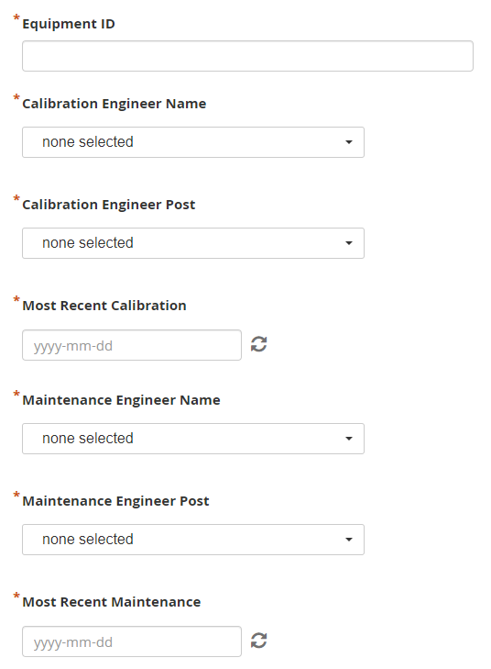

Each of the fields highlighted above are the same as those described in the Equipment Information Form section. The equipment ID must be written *exactly* as it is in the Equipment Information Form. If you are unsure how it is written look it up in the [eTool](https://travis-shinin-spot.shinyapps.io/ona_reporting_app/).

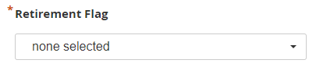

Select ‘Yes’ if this piece of equipment is going to be or has already been deactivated.

# Request Calibration Form Description

**Form url:** <https://enketo.ona.io/x/#VI2FevM7>

**Form ID:** as shown in ODK Collect: build_Request-Calibration_1573248787

**Summary:** Use this form to request a piece of equipment be calibrated.

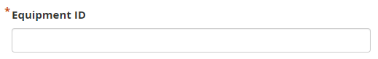

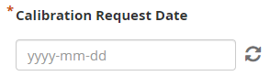

Enter the date you would like calibration **performed**.

# Request Maintenance Form Description

**Form url:** <https://enketo.ona.io/x/#OPkgR4Hc>

**Form ID:** as shown in ODK Collect: build_Request-Maintenance_1573248663

**Summary:** Use this form to request maintenance for a piece of equipment.



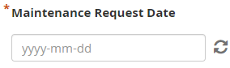

Enter the date you would like maintenance **performed**.